**Hello World application to Run locally.**

1. Making application for “Hello World” using Flask.

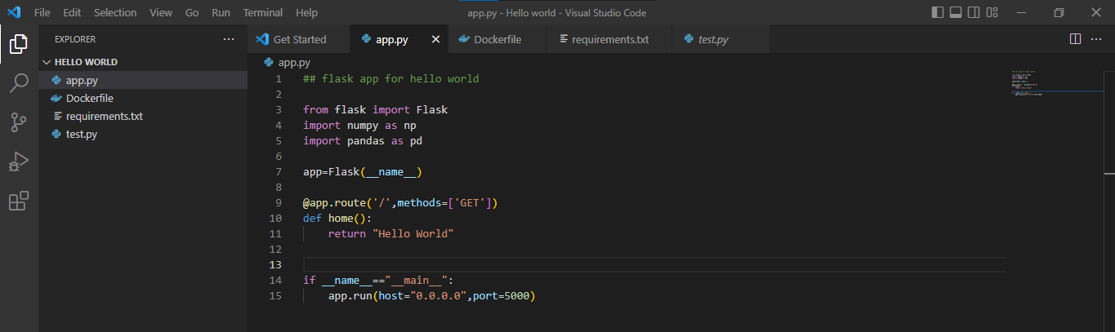

1. Creating Dockerfile.

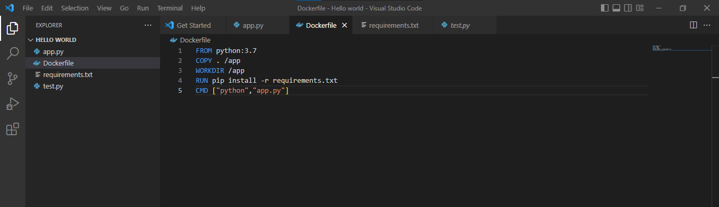

1. Creating requirements.txt file.

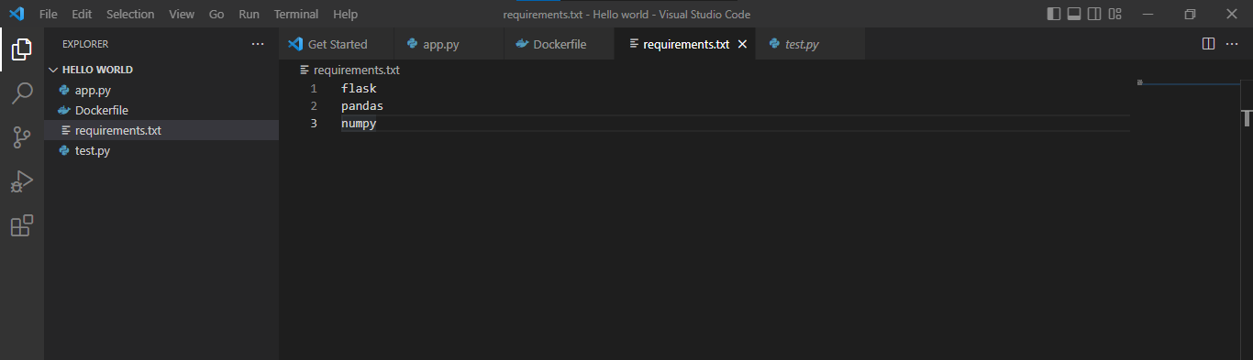

1. Installing requirements.txt.

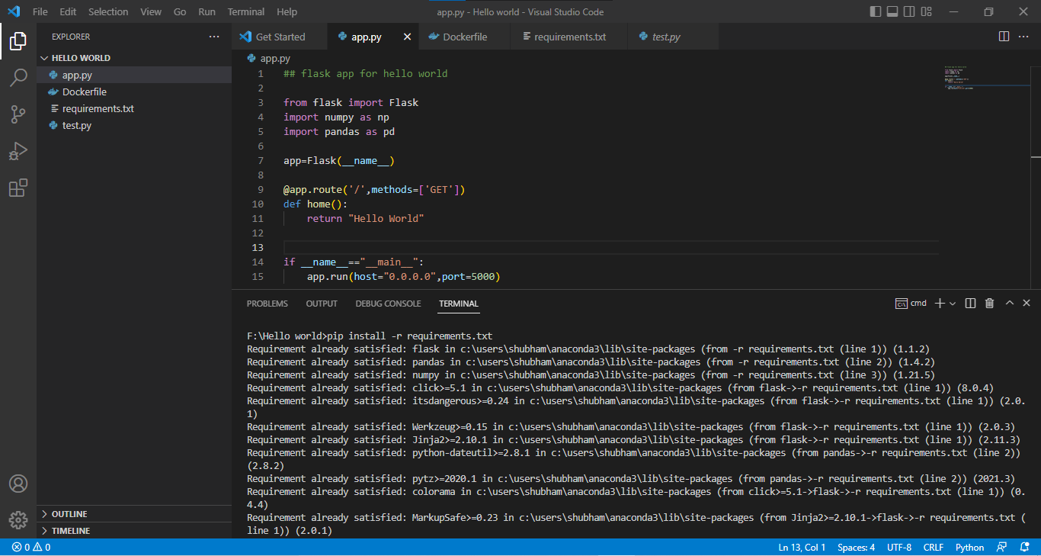

1. Building application.

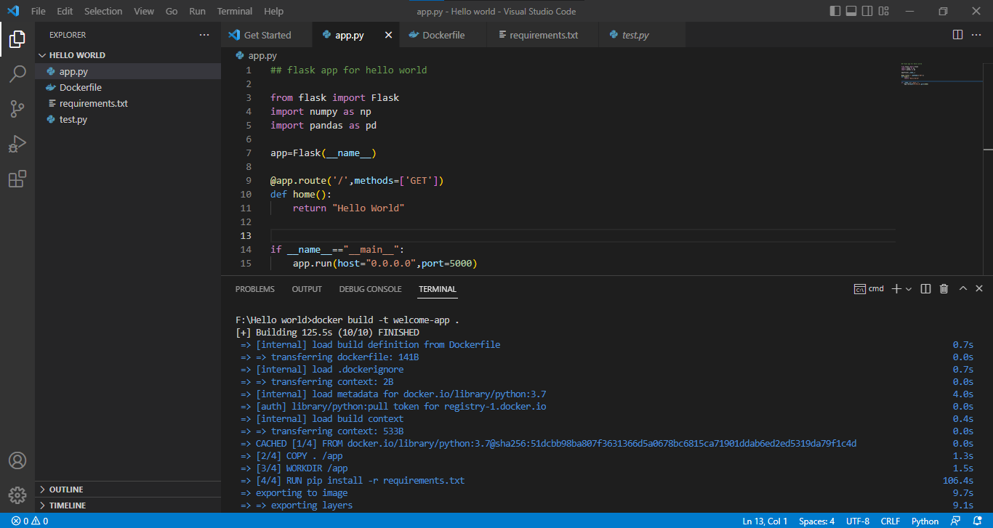

1. Docker images present in DockerHub.

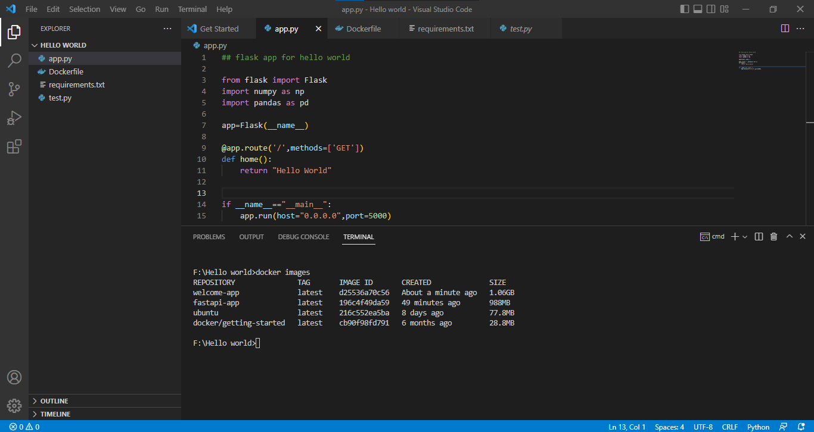

1. Running the Docker image locally.

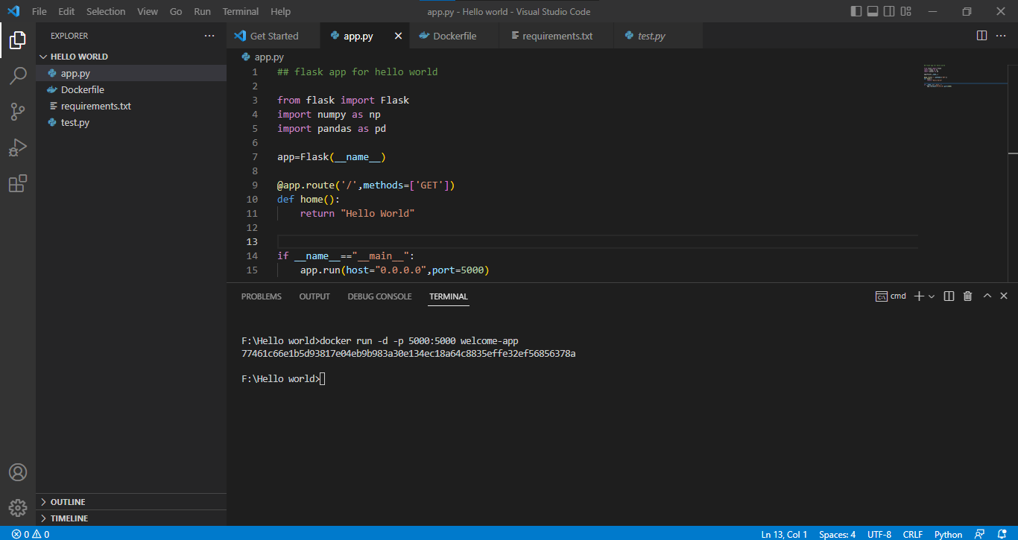

1. Docker containers which are running inside.

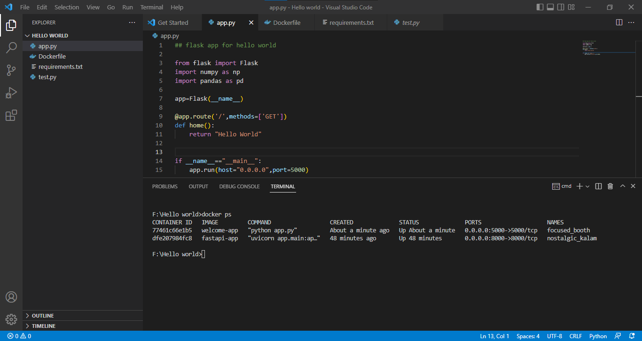

1. Final output in localhost port.

